**Chapter-6 (Practice Questions Lecture-21 )**

1. For the parallel adder in Figure, determine the complete sum by analysis of the logical operation of the circuit. Verify your result by longhand addition of the two input numbers.

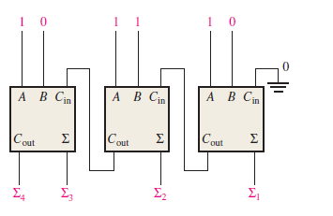 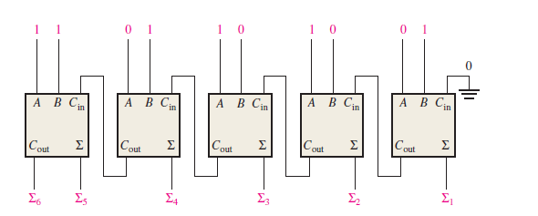

1. The circuit shown in Figure is a 4-bit circuit that can add or subtract numbers in a form used in computers (positive numbers in true form; negative numbers in complement form). (a) Explain what happens when the *Add*/*Subt*. input is HIGH. (b) What happens when *Add*/*Subt*. is LOW? ( c) assume the inputs are *Add*/*Subt*. 5 1, *A* = 1010, and *B* = 1101. What is the output?

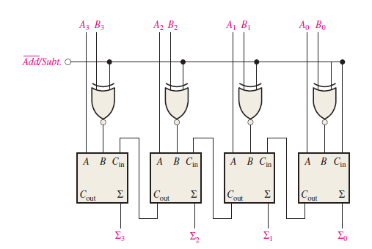

1. The input waveforms in Figure are applied to a 2-bit adder. Determine the waveforms for the sum and the output carry in relation to the inputs by constructing a timing diagram.

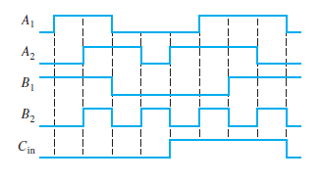

1. The following sequences of bits (right-most bit first) appear on the inputs to a 4-bit parallel adder. Determine the resulting sequence of bits on each sum output.

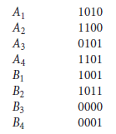

1. The waveforms in Figure are applied to the comparator as shown. Determine the output (*A* = *B*) waveform.

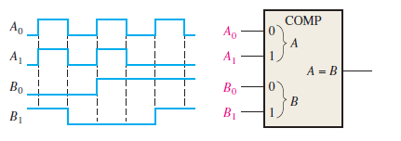

1. For the 4-bit comparator in Figure, plot each output waveform for the inputs shown. The outputs are active-HIGH.

